**EXPERIMENT-01**

1. OBJECTIVES:
2. Write a Matlab program for analyzing the effect of Vehicle drag coefficient w.r.t. vehicle velocity for following Vehicles:
   1. Vehicle 1: Cd1=0.30; A1=1.8;
   2. Vehicle 2: Cd1=0.45; A1=2.2;
   3. Vehicle 3: Cd1=0.23; A1=1.0;
3. Plot between Aerodynamic Drag Force vs velocity (km/h)
4. Plot between Power to overcome Aerodynamic Drag vs velocity (km/h)
5. Find the power to overcome aerodynamic drag at velocity (60, 80, 120 km/h) for above mentioned Vehicles.
6. SOFTWARE REQUIRED
   1. MATLAB ________
   2. Windows 10
7. PROCEDURE
   1. Open MATLAB  
      Open new M-file
   2. Type the program
   3. Save in current directory
   4. Compile and Run the program
   5. For the output see command window\ Figure window
8. PROGRAM / CODE
9. OUTPUT

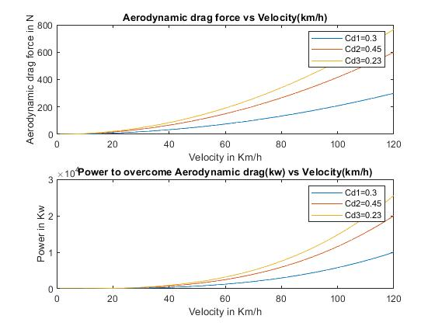

Figure 1: Sample